

***Training by Practitioners, for Practitioners***

**Hands On Learning**

**Joint practice development sessions**

**Dates:** Tuesdays, Wednesdays and Thursdays – let us know which date is best for you.

**Time:** 8.30am – 11.30am

**Venue:** St Edmund’s Nursery School & Children’s Centre, Girlington, Bradford.

**Cost:** £65 per participant per session

Our hands on training courses offer a new and innovative approach to training:

* Work alongside a practitioner delivering outstanding practice
* Help set up a rich learning environment
* Observe real adult-child interactions
* Try it out for yourself
* Evaluate children’s learning

**Wednesdays**

8.30 – 11.30

**Tuesdays**

8.30 – 11.30

Hands on learning means no sitting and listening – ideal for kinaesthetic learners, and for those who would rather be doing than watching. The training session will consist of a short introduction, followed by setting up, delivering and tidying up. There will then be chance to ask the practitioner any questions. There will be just two places available at each session.

**Thursdays**

8.30 – 11.30

**Wednesdays**

8.30 – 11.30



**Heuristic play (Birth to 2s)**

Using natural objects to encourage young children to explore the world around them. With Hazel Bennett.



**Singing and movement (3 to 4s)**

Using a Kodaly approach to developing music in young children. With Judith Brindle.



**Outdoor learning in the local area (3 – 4s)** Encouraging and inspiring young children by going out and about. With Robin Naylor.



**Studio time (3 to 4s)**

Developing creative thinking and doing with young children. With Lou Sumray, our artist in residence.

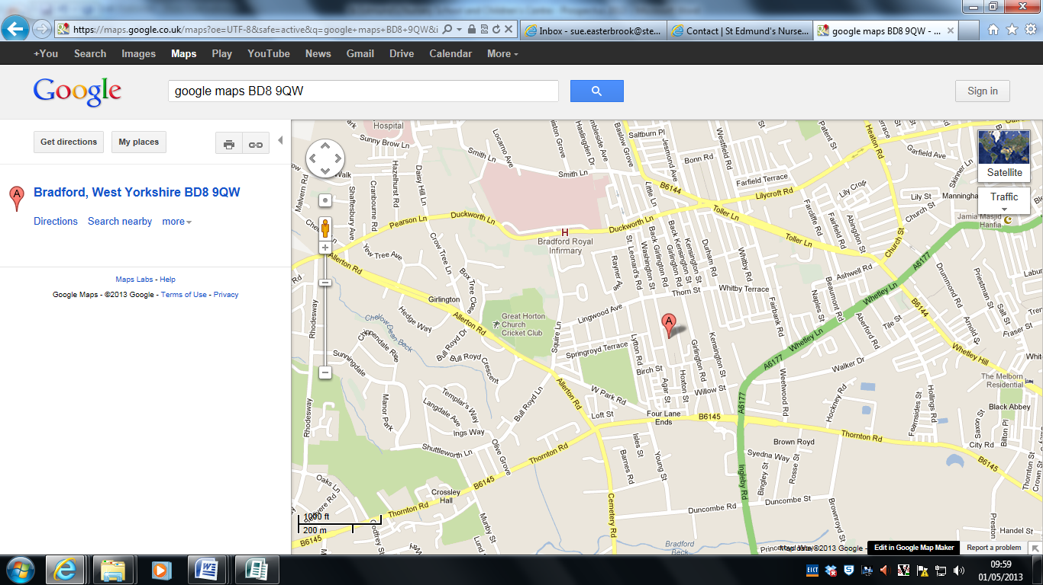**COURSE BOOKING FORM**

|  |  |
| --- | --- |
| **Course details** | |
| Course title: |  |
| Preferred date: |  |

|  |  |
| --- | --- |
| **Applicant details** | |
| Name: |  |
| Job title: |  |
| Organisation: |  |
| Contact address and postcode: |  |
| Contact phone number: |  |
| Contact email: |  |
| Dietary requirements: |  |
| Any other requirements: |  |
| How did you find out about this training? |  |

|  |  |
| --- | --- |
| **Payment details** | |
| Payment can be made by cheque or invoice.  Cancellations made later than 2 weeks before the start of a course will be non-refundable.  Cancellations made later than 4 weeks before the start of a course will be subject to a 50% charge of the total cost of your booking. | |
|  | I enclose a cheque for the cost of the training made payable to St Edmund’s Nursery School and Children’s Centre (£65) |
|  | Please send an invoice for the cost of training (£65) |

For further information, please contact Sue Easterbrook at [sue.easterbrook@stedmundsnscc.com](mailto:sue.easterbrook@stedmundsnscc.com0) or call 01274 543282.

To book a place, please return the course booking form to:

St Edmund’s Nursery School and Children’s Centre,

Washington Street, Girlington

Bradford BD8 9QW

Email [sue.easterbrook@stedmundsnscc.com](mailto:sue.easterbrook@stedmundsnscc.com0)

Please return the form as soon as possible to secure your place.